NUACA REPORT
On "3D Scanning and Data Processing"
held at the NUACA within the HERITAG Erasmus+ project

The “3D Scanning and Data Processing” course developed jointly by the faculties of NUACA within the framework of HERITAG Erasmus+ Program has been organized at the National University of Architecture and Construction of Armenia (NUACA) from October 23 to November 5, 2018 (Figure 1). Course description and Schedule are attached (see Annex 1). The course was developed and conducted by the NUACA instructor Suren Tovmasyan (Figure 2). Ten participants (signed attendance list is attached in Annex 2) have been involved in the continuation training course.
Figure 1. Participants of the continuation training course titled “3D Scanning and Data Processing” that was held at the NUACA on October 23 – November 5, 2018
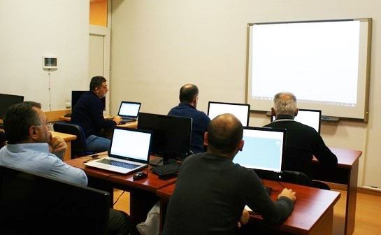

Figure 2. Instructor S.Tovmasyan during the continuation training course titled “3D scanning and Data Processing”
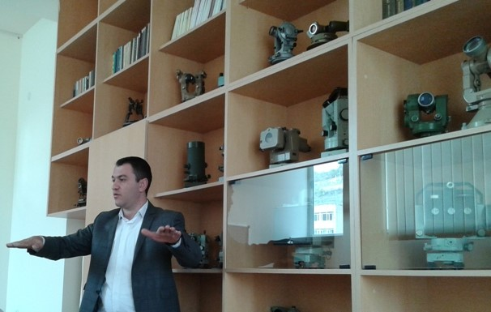

Annex 1
«3D scanning and data processing» Course Description

General Information
University | National University of Architecture and Construction of Armenia (NUACA)
Course title | 3D scanning and data processing
Course/Module code | -
Course type | Short training course
Credits awarded (ECTS) | 1.5
Dates and duration (hours) | Oct 23-Nov 05, 2018
Entry requirements/  Competences | Computer skills, Applied geodesy, photogrammetry
Responsible person/coordinator | Suren Tovmasyan, (NUACA)
Where | NUACA
Registration period | Sep 17, 2018 – Oct 20, 2018
Max/Min students | Max 10/Min 5 students
Lecturer’s details
Name, surname | Suren Tovmasyan (NUACA)
Academic title | Ph.D.
e-mail | suren.tovmasyan@mail.ru
Name, surname | Suren Tovmasyan (NUACA)
Academic title | Ph.D.
Office hours and consultation schedule | Every Tuesday, Friday and Saturday in 15:00-16:00, NUACA, Chair of Engineering Geodesy;  Every day by e-mail,
Course Structure
Course Aim and Objectives | This course presents 3D scanning technology by optical sensors and scanning techniques and shows how to obtain the best results from these technologies. This course provides the essential foundation for professionals who wish to get started in the field of new technologies for quality control and advanced metrology management.  Thus, the objectives for the course are:  - Providing an understanding about modern geodetic equiepments.  - Introducing students to software and techniques and models for making plans and digital images  - learn the workflow from the capture with a 3D laser scanner via the data analysis through to 3D modeling of the scan results.  - Identifying and accessing publicly available data sets  - Providing a knowledge about Trimble RealWorks software and package.
Short Description | The 3D laser scanning technology is used more and more in a number of fields of application. For instance, laser scanners are used more often in architecture, plant engineering and construction, aircraft construction or for the analysis of crime scenes. 3D laser scanning provides the advantage to capture an object with its surroundings completely in a minimum of time. Since laser scanning is a contact-free measurement method, you can scan a plant for instance without the need to stop the production.  Based on the scan results (point clouds), you create a complete documentation of the scan object. Subsequent remeasurements on site are not required since you can derive all needed information from the existing point cloud. Thanks to the high point density, you can assign the data to objects unambiguously. The local and global accuracy of the data is guaranteed. The scan results can serve, for instance, for creating layouts and plans, 3D models, target-actual comparisons and for the preservation of evidence. You can take maximum possibilities from your scan data.
Module/Topic | Learning Outcomes | Teaching Method | Assignments | Form of Assessment | Agenda of the Course
Lecture 1: Introduction, course overview, the main principles of 3D scanning  Lab 1: laser scanning systems | K1, S1, S3 | Interactive lecture  Q&A  Practical work | Literature: Преимущества 3D лазерного сканирования | Discussion in class, Q&A | 23.10.2018  (15:00-18:00)
Lecture 2: Laser Scanning in Engineering Surveying: Methods of Measurement | K1, S2 | Interactive lecture  Q&A | Literature: Теория и технология лазерного сканирования для пространственного моделирования територий: А.В. Комисиров. | Discussion in class, Q&A | 25.10.2018  (15:00-18:00)
Lecture 3: laser shooting practice and technology  Lab 3: Presentation of other scanning technologies | K2, S1 | Interactive lecture  Q&A  Practical work | Literature: Теория и технология лазерного сканирования для пространственного моделирования територий: А.В. Комисиров. | Discussion in class, Q&A | 26.10.2018  (15:00-18:00)
Lecture 4: The influence of the external conditions on the accuracy of laser scanning․  Lab 4: Collection of 3D scanned data | K2, S1 | Interactive lecture  Q&A  Practical work | Literature: Наземное лазерное сканирование: В.А. Середович, А.В. Комиссиров, Т.А. Широкова. | Discussion in class, Q&A | 27.10.2018  (15:00-18:00)
Lecture 5: Laser scanning and tipes of scanners  Lab 5: Laser scanning systems | K2, S1 | Interactive lecture  Q&A  Practical work | Literature: Наземное лазерное сканирование: В.А. Середович, А.В. Комиссиров, Т.А. Широкова. | Discussion in class, Q&A | 30.10.2018  (15:00-18:00)
Lecture 6: The main principles of measurement of the 3D scanner  Lab 6: ranging of errors in laser scan results, Data analyzing | K2, S1, | Interactive lecture  Q&A  Practical work | Literature: The main principles of measurement of the 3D scanner | Discussion in class, Q&A | 01.11.2018  (15:00-18:00)
Lecture 7: The advantages and disadvantages of 3D scanning  Lab 7: The main principles of measurement of the 3D scanner | K2, S5 | Interactive lecture  Q&A  Practical work | Literature: The advantages and disadvantages of 3D scanning | Discussion in class, Q&A | 03.11.2018  (15:00-18:00)
Lecture 8: Data analyzing, Data collection and data quality  Lab 8: Data Trimble Real Works program | K2, K3, S4, S6, A1, A3 | lecture | Literature: 3D scanning and data analyzing Data Trimble Real Works program | Discussion in class, Q&A | 04.11.2018  (15:00-18:00)
Lecture 9: Network analysis  Lab 9: Ground 3D laser scanning, Trimble TX8 | K2, K3, S4, S6, A1, A3 | Interactive lecture  Q&A  Practical work | Literature: Ground 3D laser scanning, Trimble TX8 | Own analysis and map presentation | 05.11.2018  (15:00-18:00)
Teaching and Assessment Requirements | Teaching: The students of the course should abide the following requirements: attending the classroom for lectures, active participation in class discussions, practice work and individual work. Students are expected to attend all class sessions as listed on the course calendar. The best way to contact Instructor outside of the class hours is via email.  Assessment: Assessment will be based on student’s individual work.
Resources | PC for all students, Internet

Learning Outcomes
Knowledge | K1 - Understand the fundamental theory of 3D laser scanning  K2 - Become proficient in the use of laser scanning information for creating digital models and analyzing  K3 - Collection of 3D scanned data and Trimble RealWorks system
Skills | S1 - Express an understanding about 3D scanning technologies.  S2 - Express an understanding about laser scanners.  S3 - Produce digital images and layouts․  S4 – Understand measurement principles;  S5 – Collect 3D scanned data  S6 – data base development
Attitudes | A1 – Create working drawings;  A2 - Become efficient in Ground 3D laser scanning

Annex 2. Attendance List of training on “3D Scanning and Data Processing” course.
List of Attendance
”3D Scanning and Data Processing” short course
